

MAJOR PROJECT REPORT

ON

***“*VASTRA*”***

**Diploma in Computer Science & Engineering**

(Batch: 2021-2024)

# Submitted To: Submitted By:

Miss. Anushka Rajpoot

(Lecturer) Brajdeep Singh(**2135000014**)

Deepak Sain(**2132000024**)

Mritunjay Kumar(**2135000035**)

**GLA UNIVERSITY, MATHURA**

**(Affiliated to NAAC A+ Grade)**

**Mathura- 281406, INDIA**

# CERTIFICATE

This is to certify that We Brajdeep Singh(**2135000014**), Deepak Sain(**2132000024**)

and Mritunjay Kumar(**2135000035**) of Diploma (CSE) 6th Semester from GLA University,

Mathura has presented this Major project work entitled “VASTRA”, an app in partial fulfilment of the

requirements for the award of the Degree of Diploma in Computer Science Engineering under our

supervision and guidance.

Supervisor:

Miss. Anushka Rajpoot

Lecturer,

Dept. Of CS

**ABSTRACT**

The time has gone when people have to go and search on different shops for the things they

want as now days there are several shopping sites available. E-commerce is a boom in field of technology, making life easier and luxurious i.e., shopping through internet by sitting at a place. This website work was inspired by the immense inconvenience faced by the people, especially who don't have much time to waste by going market and who have the desire of finding out variety at a place. People can easily go through this website and search for the things they want according to their needs and can make it order easily and in convenient manner.

# ACKNOWLEDGEMENT

It gives me a great sense to present the report undertaken during Diploma Sixth Semester. I owe special debt of gratitude to Miss. Anushka Rajpoot, Department of Computer Science Engineering. GLA University Polytechnic, Mathura for their constant support and guidance throughout the course of my work. Her sincerity. thoroughness and perseverance have been a constant source of inspiration for me. It is only their cognizant that my endeavours have seen light of the day.

We also take the opportunity to acknowledge the contribution of Dr. Vikas Sharma, Principal University Polytechnic, GLA University, Mathura for their full support.

I also do not like to miss the opportunity to acknowledge the Contribution of, Miss. Anushka Rajpoot , Mr. Aditya Gautam, Mr. Rohan Singh, Mr. Vineesh Kumar Singh and all the faculty members of the department for their Kind assistance and co-operation during the development of my report. Last but not the least, I acknowledge my family members , my friends for their contribution in the completion of the project.

Sign:

Brajdeep Singh **(2135000014**)

Deepak Sain (**2132000024**)

Mritunjay Kumar(**2135000035**)

# TABLE OF CONTENTS

## Chapter 1. Introduction ....................................................................................

**1.1 Client Identification/Need Identification/Identification of relevant**

**1.2 Contemporary issue ......................................................................................**

**1.3 Identification of Problem .......................................................................................**

**1.4 Identification of Tasks...............................................................................................**

**1.5 Timeline ...........................................................................................................................**

**1.6 Organization of the Report ...........................................................................................**

## Chapter 2. Literature Review/Background Study

**.................................................**

**2.1 Timeline of the reported problem .................................................................................**

**2.2 Proposed solutions ....................................................................................................**

**2.3 Bibliometric analysis .................................................................................................**

**2.4 Review Summary .....................................................................................................**

**2.5 Problem Definition ...............................................................................................**

**2.6 Goals/Objectives ..................................................................................................**

## Chapter 3. Design Flow/Process

**.........................................................................**

**3.1 Evaluation & Selection of Specifications/Features ...................................................**

**3.2 Design Constraints .................................................................................................**

**3.3 Analysis and Feature finalization subject to constraints ...........................................**

**3.4 Design Flow ...........................................................................................................**

**3.5 Design selection ......................................................................................................**

**3.6 Implementation plan/methodology ........................................................................**

**3.7 Data Flow Diagram …………………………………………………..**

## Chapter 4. Results Analysis and Validation .....................................................................

**4.1 Implementation of solution .......................................................................................**

## Chapter 5. Conclusion and Future Work ........................................................................

**5.1 Conclusion ..............................................................................................................**

**5.2 Future work ............................................................................................................**

**Referen ces Append ix**

# CHAPTER – 1

**INTRODUCTION**

## Identifying the Need

In the ever-evolving fashion landscape, the demand for a platform offering high-quality, stylish,

and sustainable clothing is paramount. This need is substantiated through extensive research, user feedback, and real-world scenarios, highlighting the challenges fashion-conscious individuals face purchase sustainable fashion effortlessly.

our endeavors in transforming Vastra.com into a leading fashion e-commerce destination.

In the dynamic realm of online fashion, the imperative for a platform providing high-quality, stylish, and sustainable clothing is evident. This necessity is validated through thorough research, user feedback, and real-world scenarios, underscoring the challenges faced by individuals seeking to purchase sustainable fashion effortlessly. These insights fuel our commitment to evolving Vastra.com into a premier fashion e-commerce destination, dedicated to meeting the evolving needs of fashion-conscious consumers.

## Defining the Problem

The overarching challenge for Vastra.com lies in optimizing the online fashion shopping experience. This entails creating a platform where users can effortlessly explore and discover stylish and sustainable clothing by specifying their preferences, such as style, size, and occasion. Importantly, at this stage, our focus is on articulating the problem without hinting at specific solutions, ensuring a thoughtful and user-centric resolution

## Identifying Tasks

Effectively addressing the challenges faced by Vastra.com, we systematically identified and categorized tasks across different project stages, encompassing identification, development, and testing. These tasks form the cornerstone for organizing the report, structuring chapters, headings, and subheadings to guide our exploration and analysis in the development journey of Vastra.com..

## Setting the Timeline

Vastra.com adheres to a well-defined timeline, illustrated through a Gantt chart, outlining crucial milestones and deadlines. This visual representation is instrumental in orchestrating efficient task management, guaranteeing a systematic and timely execution of the project for the successful development of Vastra.com.

## Organization of the Report

This report provides a thorough understanding of Vastra.com, with each chapter contributing to the project's progress. It begins by exploring identified needs and challenges, followed by a detailed breakdown of tasks. The timeline sets the pace, and readers can expect insights and findings distributed across the chapters, offering a comprehensive view of Vastra.com's development..

As we embark on this journey, the following chapters will unfold, offering a holistic view of the development and implementation of Vastra.com.

# CHAPTER - 2

**LITERATURE REVIEW/BACKGROUND STUDY**

## Timeline of the Reported Problem

To grasp the global context of fashion challenges, we delved into the timeline of reported issues. Our investigation spanned incidents worldwide, supported by documentary proof. This historical exploration aided in understanding the evolution of challenges related to finding optimal and sustainable fashion choices.

## Proposed Solutions

We examined past efforts to address challenges in the fashion domain, analyzing proposed solutions to understand their features, effectiveness, and drawbacks. Through a review of existing solutions, our goal was to glean insights from past experiences and identify opportunities for improvement in the development of Vastra.com..

## Bibliometric Analysis

A thorough bibliometric analysis was undertaken to assess existing literature in the fashion domain. Focusing on key features, effectiveness, and drawbacks of globally implemented solutions, this analysis allowed us to synthesize information and gain insights into the current state of online fashion retail applications. These insights informed our approach to building an innovative solution with Vastra.com.

## Review Summary

Connecting our discoveries from the literature review, we summarized key insights directly relevant to the development of Vastra.com. This alignment between existing knowledge and our project's objectives ensures that we build upon valuable lessons learned from the broader field of online fashion retail applications.

## Problem Definition

With a clear understanding of the historical context and existing solutions, we defined the problem Vastra.com aimed to address. This involved specifying what needed to be done, how we intended to do it, and establishing boundaries for the project. The problem definition became a guiding framework for the subsequent design and development stages.

## Goals/Objectives

Aligned with the problem definition, we set specific and measurable goals for Vastra.com. These goals served as milestones during the project, providing a roadmap for our work. The objectives were designed to be narrow, precise, tangible, and concrete, ensuring that each step contributes directly to the success of Vastra.com and can be validated or measured.

By conducting a thorough literature review and aligning our project objectives with the insights gained, Vastra.com is positioned to offer an innovative and effective solution in the realm of online fashion retail applications.

# CHAPTER – 3 DESIGN OF THE SYSTEM

## Crafting an Intuitive Fashion Portal

Utilizing HTML, CSS, and JavaScript exclusively, Vastra.com is meticulously designed for an engaging and responsive user interface. Users seamlessly navigate the fashion portal, specifying preferences like style and size. The application, structured with these core technologies, dynamically presents a curated collection of clothing items with corresponding details.

## Implementing Secure User Authentication

In ensuring secure user authentication, Vastra.com employs HTML, CSS, and JavaScript for the frontend. Users can register and log in securely using their credentials.

Vastra.com exclusively relies on client-side technologies for user authentication, prioritizing simplicity and efficiency

## Real-time Data Dynamics in Vastra.com

To ensure real-time updates on fashion items, Vastra.com seamlessly integrates APIs into the backend. This empowers the platform to fetch and display up-to-date product details.Vastra.com relies on HTML, CSS, and JavaScript for a simplified yet effective approach, ensuring a dynamic and accurate shopping experience.

## Collaborative Development with Git and GitHub

For smooth collaboration and version control, we employed Git and GitHub. Multiple developers can work on the project simultaneously, tracking changes, and ensuring a stable codebase. This collaborative approach helps maintain consistency and facilitates efficient development.

## Coding in Visual Studio Code

The actual coding process took place in Visual Studio Code, providing a streamlined and developer-friendly environment. This powerful code editor enhances productivity, offering features like syntax highlighting, debugging, and extensions, making the development process efficient and enjoyable.

## Testing and Iterating

After coding, Vastra.com underwent comprehensive testing to ensure its functionality and responsiveness. Testing involved simulating various user scenarios, validating authentication security, and confirming the accuracy of product information. Any identified issues were promptly addressed, and improvements were iteratively implemented to enhance the overall user experience.

## Creating the Implementation Plan

Throughout the design process of Vastra.com, we crafted a comprehensive implementation plan. This plan intricately mapped out the integration of frontend and backend technologies, API connections, and the authentication system. Serving as a guide, this plan ensured the development of Vastra.com was cohesive and well-executed, resulting in a seamless online fashion platform.

Vastra.com seamlessly combines HTML, CSS, and JavaScript to provide users with a seamless and secure online fashion shopping experience, allowing easy exploration and account management.

**3.7 Data Flow Diagram**

**DFD** is the abbreviation for **Data Flow Diagram**. The flow of data of a system or a process is represented by DFD. It also gives insight into the inputs and outputs of each entity and the process itself. DFD does not have control flow and no loops or decision rules are present. Specific operations depending on the type of data can be explained by a flowchart. It is a graphical tool, useful for communicating with users ,managers and other personnel. it is useful for analyzing existing as well as proposed system.

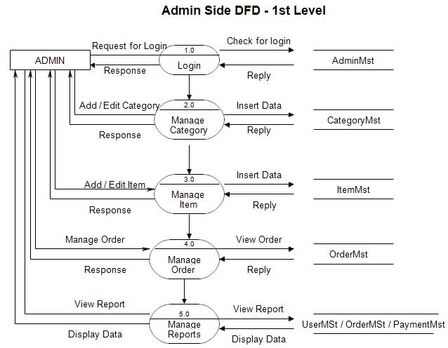

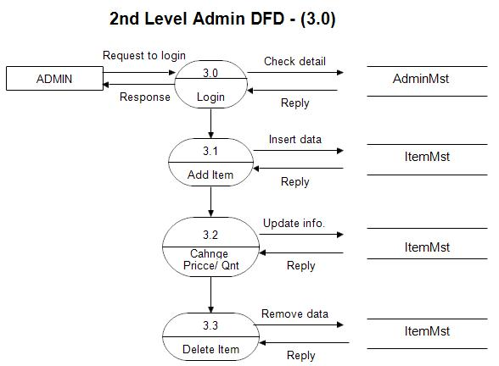

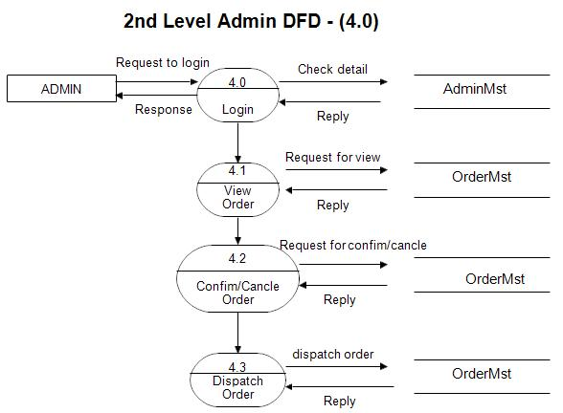

# CHAPTER - 4

**RESULTS ANALYSIS AND VALIDATION**

## Implementation of Solution

In crafting Vastra.com, we employed tools to ensure a smooth and optimal user experience for exploring and purchasing fashion items. Our process involved:

## Data Insight

We utilized modern tools to analyze data from fashion APIs, gaining insights into trends and user preferences. This informed the platform's design and functionality, aligning it with user expectations.

## Strategic Planning

Before developing Vastra.com, we created visual plans to enhance user interaction and ensure a user-friendly experience, making fashion exploration and purchase straightforward..

## Documentation

Detailed reports were crafted to explain our choices, address challenges, and provide guidance for future development, ensuring transparency and a well-documented development process.

## Organizational Tools

We utilized effective communication and organizational tools to streamline collaboration, ensuring everyone was aligned with tasks and facilitating efficient problem-solving.

## Rigorous Testing

Prior to launch, Vastra.com underwent extensive testing to simulate user scenarios and guarantee optimal functionality. This iterative testing process instilled confidence in the platform's ability to deliver an exceptional fashion shopping experience based on user preferences and trends.

# CHAPTER - 5

**CONCLUSION & FUTURE WORK**

## Conclusion

In conclusion, the Vastra.com project embodies an innovative e-commerce platform designed to empower users in their pursuit of high-quality, stylish, and sustainable clothing. Built on a streamlined technological foundation comprising HTML, CSS, and JavaScript, Vastra.com is positioned to redefine the online fashion shopping experience.

Anticipated to be completed within a month, the Vastra.com team is dedicated to delivering a user-friendly and efficient platform. By providing users with a seamless interface to explore and purchase clothing, the project aligns with the evolving needs of fashion-conscious individuals.

The team is confident in achieving project objectives, drawing from a comprehensive understanding of user requirements and leveraging cutting-edge technologies in HTML, CSS, and JavaScript for a collaborative development approach.

## Future Work

As Vastra.com enters the post-development phase, several avenues for future work come into focus:

* + 1. **Feature Enhancement**

Continued refinement of Vastra.com can involve feature enhancement. The team aims to iterate on the application, incorporating additional functionalities that enhance the overall user experience. This may include refining search algorithms, introducing personalized user preferences, and expanding the scope of tracked fashion information.

* + 1. **Technological Advancements**

To stay at the forefront of innovation, future work will entail staying abreast of technological

advancements. This involves periodic updates to the technological stack, ensuring that Vastra.com remains compatible with the latest frameworks and industry standards.

The integration of emerging technologies may also be explored for further optimization.

* + 1. **User Community Engagement**

A critical aspect of future work for Vastra.com is engaging with the user community. Establishing a feedback loop and actively seeking user insights will be prioritized. This iterative approach allows for continuous improvements based on user feedback, ensuring that Vastra.com evolves in tandem with user expectations, providing a more personalized and satisfying fashion shopping experience.

* + 1. **Global Expansion**

Looking beyond the initial release, there is potential for global expansion for Vastra.com. Future efforts may focus on integrating additional clothing brands, supporting a broader range of fashion styles, and adapting the application to cater to diverse international markets. The aim is to provide a comprehensive and inclusive online fashion shopping experience for users worldwide..

In summary, the future work for Vastra.com encompasses a commitment to ongoing improvement, technological currency, user engagement, and potential global scalability. By embracing these aspects, Vastra.com aims to not only meet but exceed user expectations in the dynamic landscape of online fashion shopping applications. The continuous dedication to innovation and user satisfaction positions Vastra.com as a leading platform in the ever-evolving fashion e-commerce industry.

# REFERENCES

1. HTML – Hyper Text Markup Language, the standard markup language for documents designed to be displayed in a web browser. (<https://html.spec.whatwg.org/multipage/>)
2. CSS - Cascading Style Sheets, a style sheet language used for describing the look and formatting of a document written in HTML. (<https://www.w3.org/Style/CSS/Overview.en.html)>
3. JavaScript - A high-level, interpreted programming language that conforms to the ECMAScript specification. (<https://developer.mozilla.org/en-US/docs/Web/JavaScript>)
4. BootStrap - A free and open-source CSS framework directed at responsive, mobile-first front-end web development. (<https://getbootstrap.com/>)

The VASTRA team acknowledges the invaluable contributions of the above technologies, frameworks, and resources that played a pivotal role in the conceptualization and development of the VASTRA web application.

